Migration of Workloads to Azure Stack with Veeam B&R



Kenny Lowe  
Senior Principal Product Technologist – Azure Stack

Microsoft MVP, Azure Stack

**Dell EMC** | Microsoft Hybrid Cloud

kenny.lowe@dell.com

@KennyLowe

Contents

Purpose 2

Intended Audience 2

Source Environment 2

Target Environment 3

Lift and Shift Migration Procedure with Veeam Solution 4

Initial Veeam Deployment 4

Initial Veeam Configuration 11

Backup Virtual Machine from Source Environment 17

Restore Virtual Machine to Target Environment 21

Post Migration Verification Steps in Target Environment 30

# Purpose

This guide will help you to understand:

* The core functionality in Veeam Backup and Replication which enables migration or restoration of workloads to Azure Stack
* How to deploy the core Veeam components required to restore to Azure Stack
* How to easily lift and shift workloads into Azure Stack from VMware, Hyper-V, or physical servers using Veeam B&R
* How network address space can be recreated in Azure Stack, removing the need to re-IP servers

This guide is NOT:

* A step by step guide to all Veeam products or configuration variants. Only a core/basic setup is shown in order to create the pre-requisite environmental conditions.
* The only way to migrate workloads into Azure Stack. See other guides in this series for further options for migration/restoration.
* Authoritative – it is intended to show the process and high level steps, but does not necessarily capture all the nuance when deploying the Veeam suite for production.

# Links

To download the Veeam solution check:

* <https://www.veeam.com/virtual-machine-backup-solution-free.html>
* <https://www.veeam.com/blog/how-to-get-free-veeam-nfr-key.html>

# Intended Audience

This guide is targeted towards individuals involved in backup, recovery, or migration of existing workloads to Azure Stack, using Veeam Backup and Recovery v9.5 Update 4 or newer. The example provided in this guide is a SQL workload on a Windows Server, however most Windows or Linux1 workloads can be migrated in this manner.

1 Linux workloads require a helper to be deployed in the Azure Stack environment, the guide for which falls outwith the scope of this document.

# Source Environment

The source environment for this scenario is a Hyper-V server with a number of virtual machines running within it.

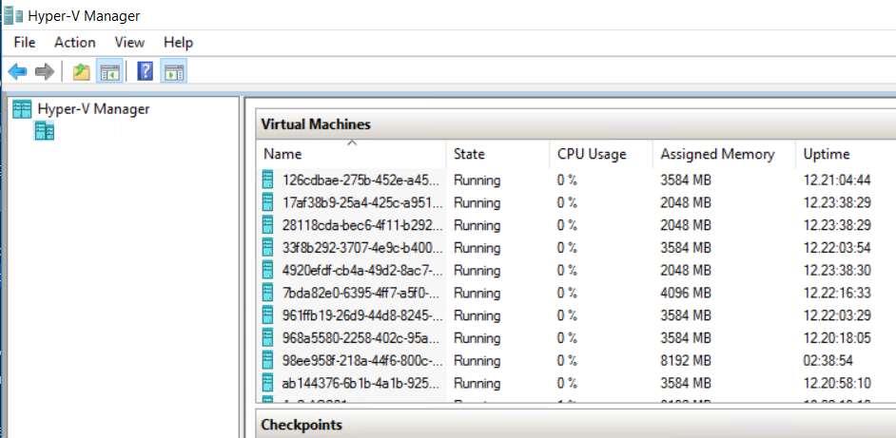

The source virtual machine is named AzS-SQL1, and is deployed with 2 VCPU, 4GB RAM, and 2 VHDs.

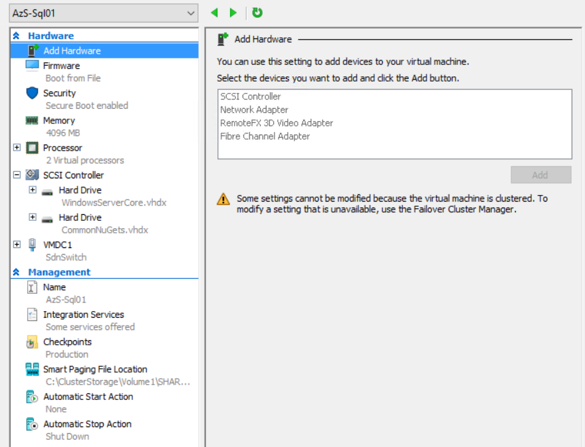

# Target Environment

The Target Environment is an Azure Stack Development Kit (ASDK) running the 1902 release of Azure Stack. In a production scenario a multi-node Azure Stack is required in order to perform these steps. For dev/test purposes, an ASDK is capable of validating all steps other than those which are performance-related. Please note, if testing restoration from an existing Veeam implementation to an ASDK as opposed to working entirely within the bounds of the ASDK’s networking, it’s necessary to perform some initial network modifications as documented [here](https://community.emc.com/docs/DOC-71493).

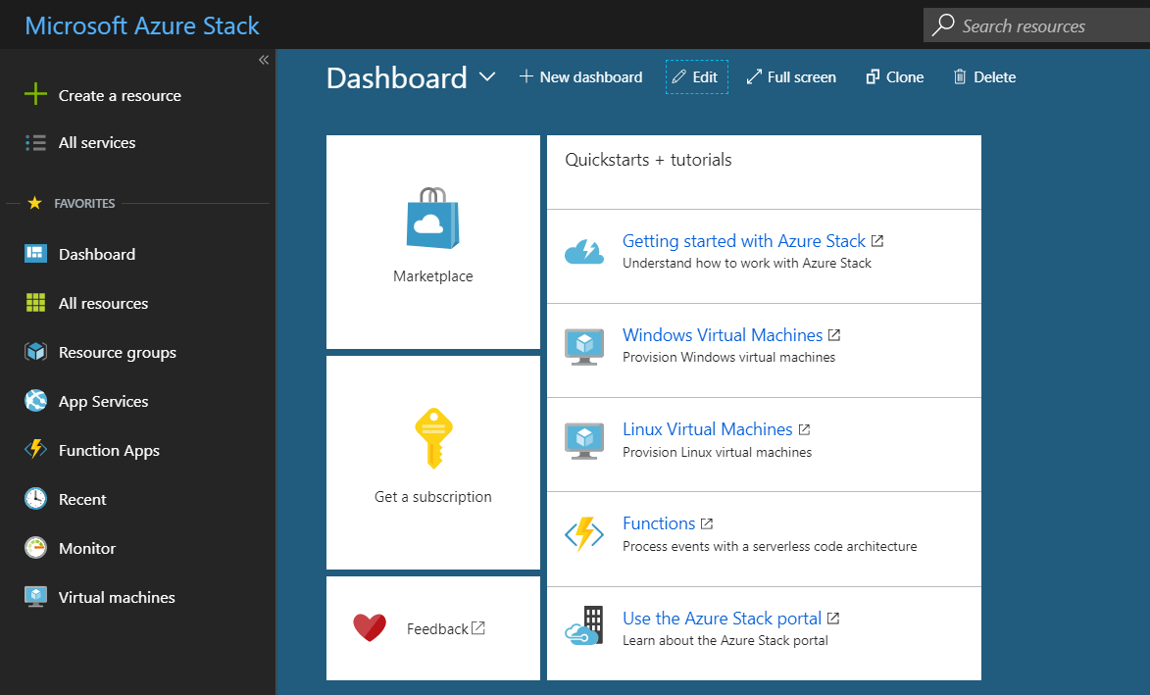

# Lift and Shift Migration Procedure with Veeam Solution

## Initial Veeam Deployment

The Veeam backup infrastructure should be deployed to meet the pre-requisites documented [here](https://www.veeam.com/veeam_backup_9_5_u4_release_notes_rn.pdf) under the ‘Veeam Backup and Replication Server’ section, as well as the subsequent three sections covering Console, Proxy, and Repository servers. For the purposes of this guide, all required roles will be co-located on a single Windows Server 2016 Virtual Machine. In production, these should be architected and distributed according to Veeam best practices.

Sufficient storage to hold backups should be presented to the Veeam server. There are a number of ways to achieve this which will be touched on during the installation documentation, in this instance a virtual disk is presented to the Veeam Server which is mounted as drive F:, formatted as REFS with a 64kb block size.

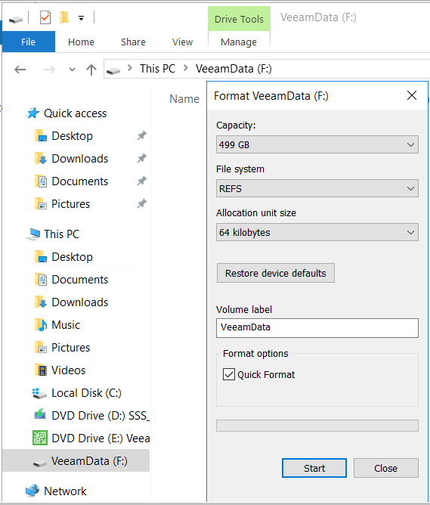

Download the Veeam Backup and Replication installation files from the Veeam Download portal [here](https://my.veeam.com/#/my-products). You will also need to obtain a Veeam license file for deployment. Free Not for Resale (NFR) licenses are easily available from Veeam for test purposes covering a multitude of industry recognized certifications and community champion awards. More information is available [here](https://www.veeam.com/blog/how-to-get-free-veeam-nfr-key.html).

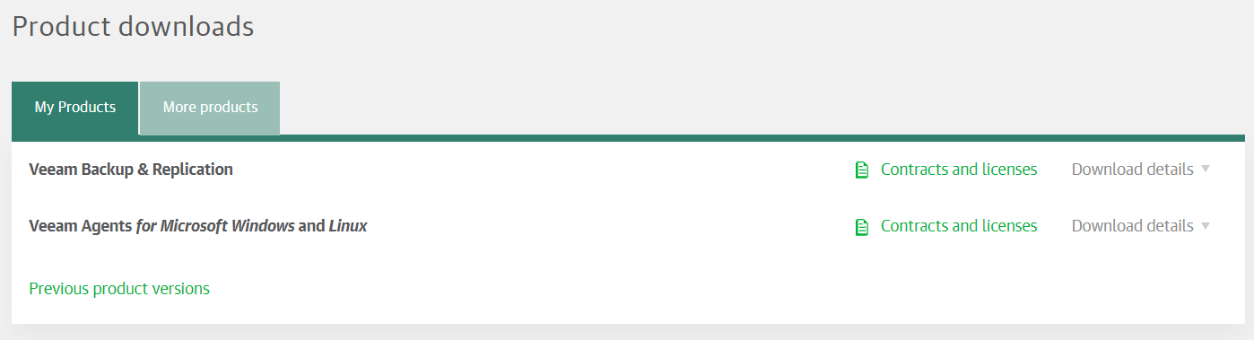

Download the latest version of Veeam Backup and Replication, making sure it’s at a minimum version 9.5 Update 4, as this is the first version to contain Direct Restore to Azure Stack functionality. Mount the ISO on the Veeam server.

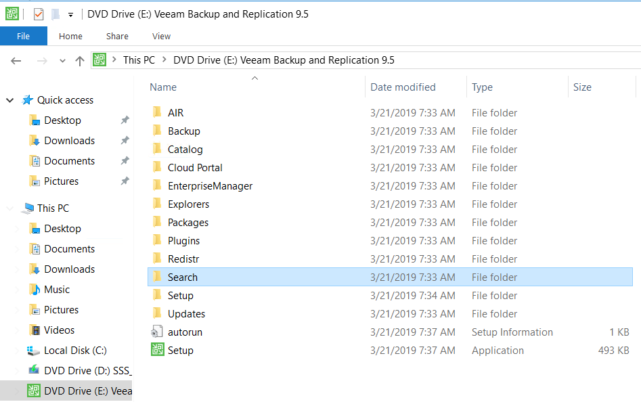

Launch the Setup application and select the Install button.

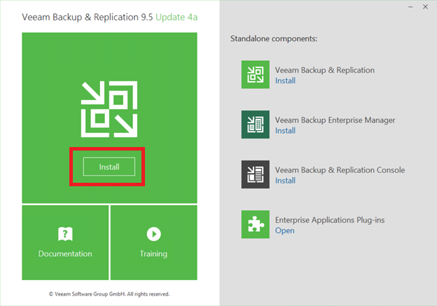

Accept the license agreements.

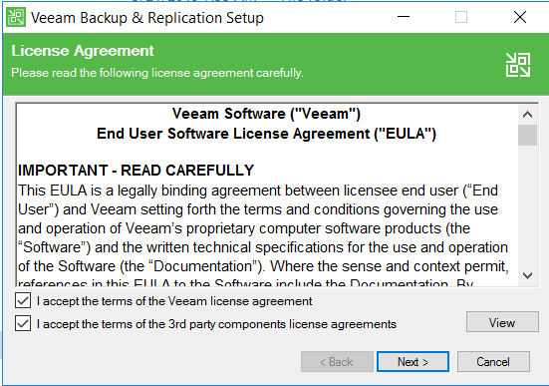

Select the license file you’ve been provided by Veeam, either as a paid for offering or as an NFR license you’ve obtained for dev/test purposes.

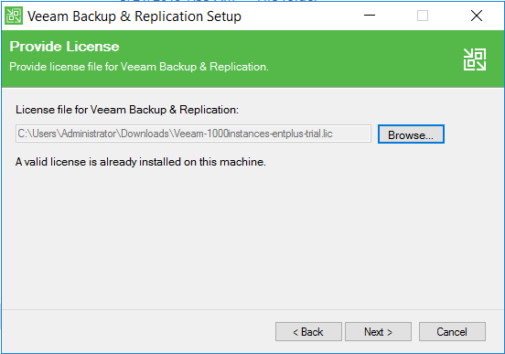

Ensure all components are selected for install. If you have a location other than the C: drive you prefer application components to be installed, change that at this point. Note that this is just for the application components, not for the backup files.

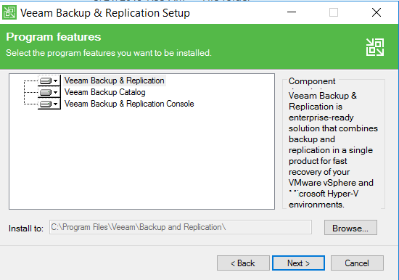

If required pre-requisite components are not installed, select the ‘Install’ option, and all pre-reqs will be automatically installed.

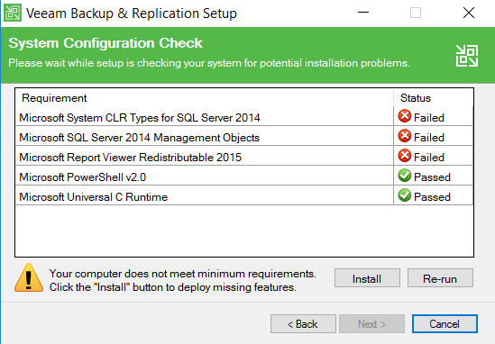

Once pre-requisites have been installed and all are showing as Passed, select Next.

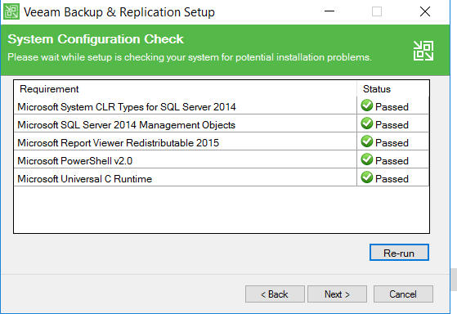

For SQL server components, an existing SQL server can be utilised, which can either run on the Veeam server or on a separate server/cluster. For the purposes of this guide, a new instance of SQL Express will be installed by the Veeam installer on the Veeam server by selecting ‘Install new instance of SQL Server’.

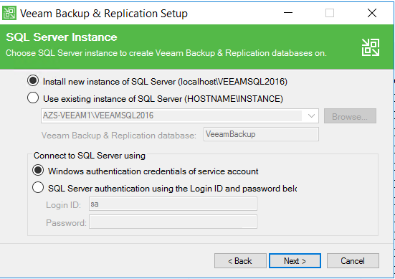

Once all configuration is set and validated, select ‘Install’.

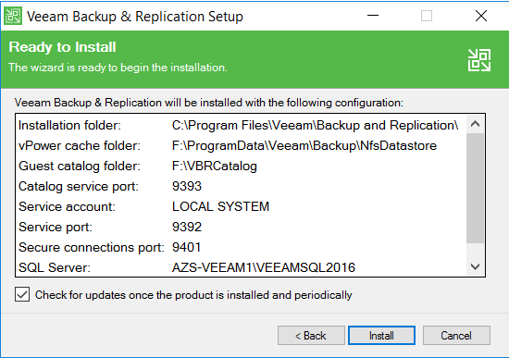

Once installation is complete, click Finish to exit the installer.

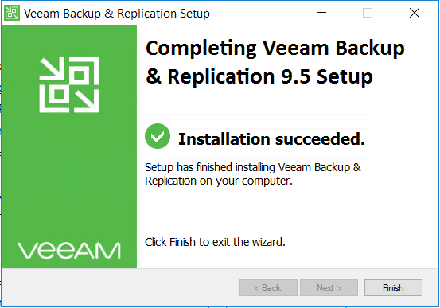

## Initial Veeam Configuration

Launch the Veeam Backup and Replication Console from the Veeam Server’s desktop, and login with appropriate credentials.

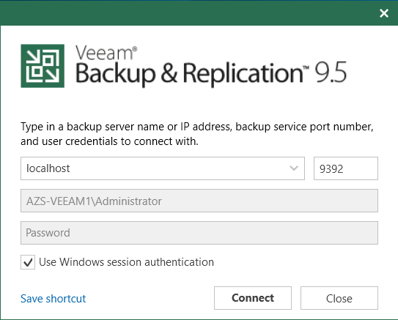

The initial page that is launched is the Jobs page in the Home tab, but as there is no configuration done yet, we need to click on the ‘Backup Infrastructure tab to start configuring the environment.

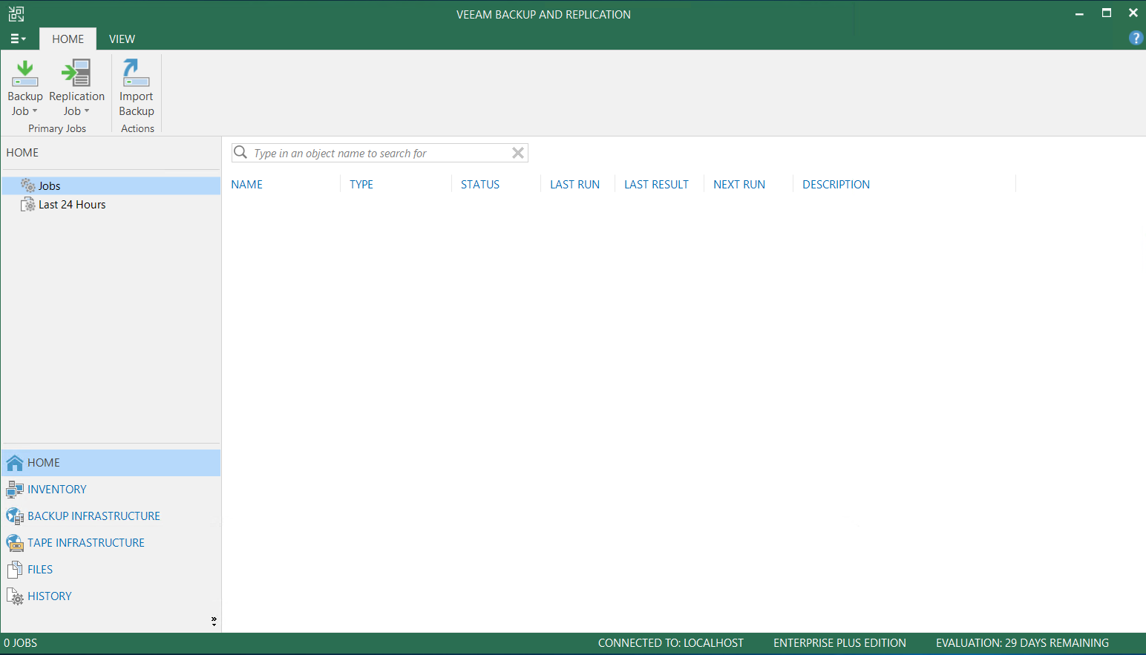

Select ‘Backup Repositories’ to see configured repositories. In this case, the F: drive has been selected as backup target, with a folder of ‘Backup’. This is absolutely perfect for this case, as that’s the correct drive, so no change to configuration is required. To see other options available, click the ‘Add Repository’ button.

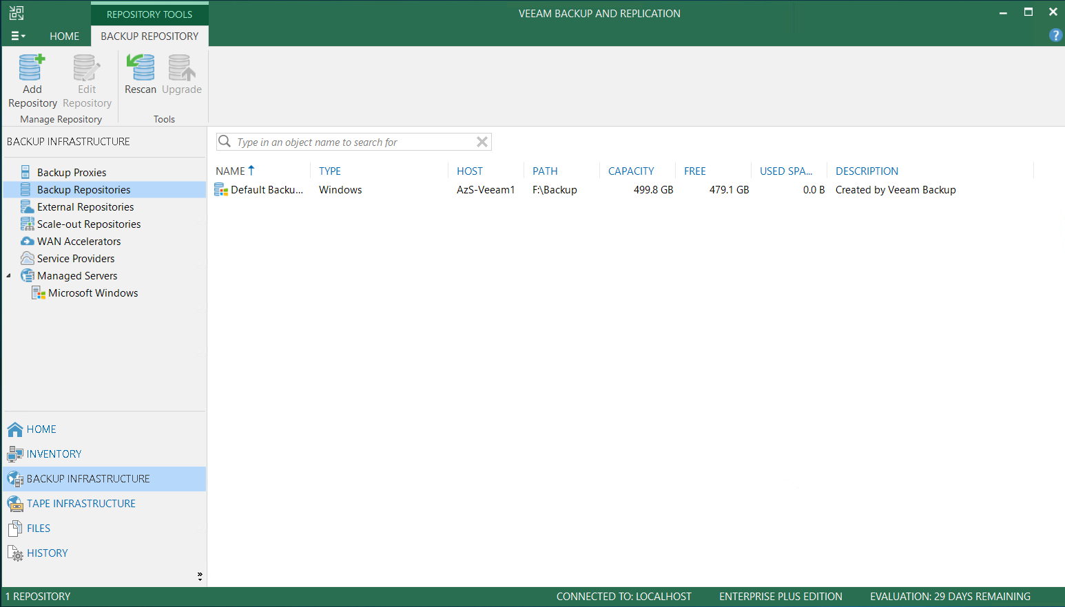

Here you can see several options for where to hold backup data including Direct Attached, Network Attached, Dedup Appliance such as Dell EMC Data Domain, or Object Storage like Azure Blob. Cancel out if using locally attached storage which is already configured like in our case, or continue on to add your appropriate repository type.

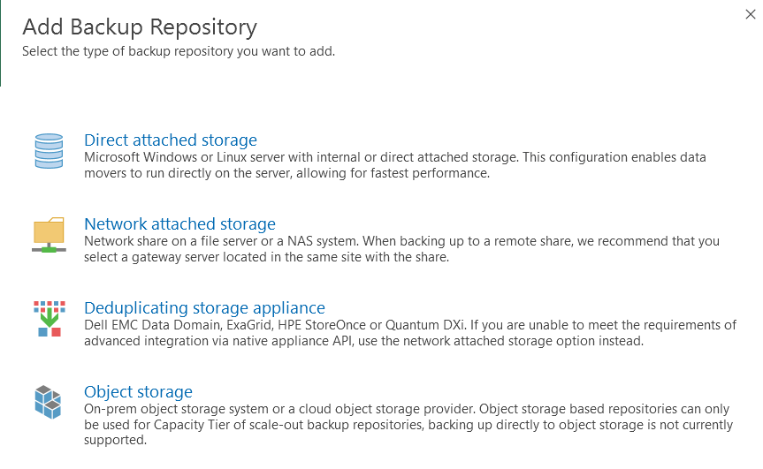

Once a repository is configured, it’s necessary to add one or more target servers to backup. Click on the Managed Servers option, and select ‘Add Server’.

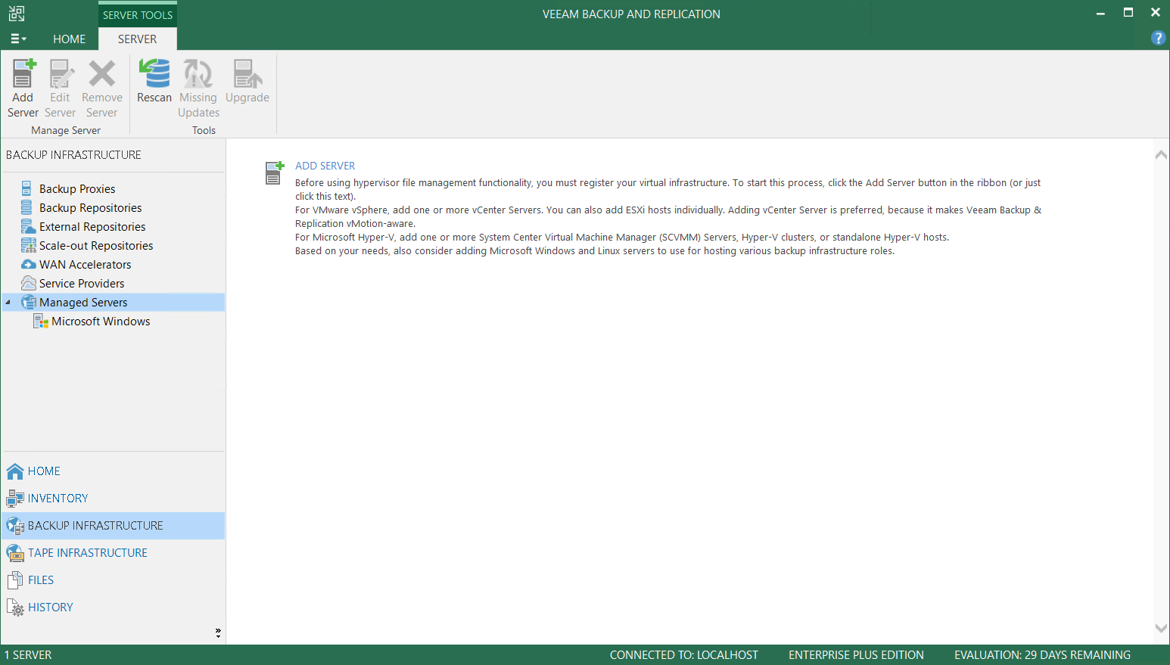

Again there are various options available to add as backup targets, including VMware, Hyper-V, or standalone Windows or Linux servers, either virtual or physical. The target in this lab is a standalone Hyper-V server, so select ‘Microsoft Hyper-V’.

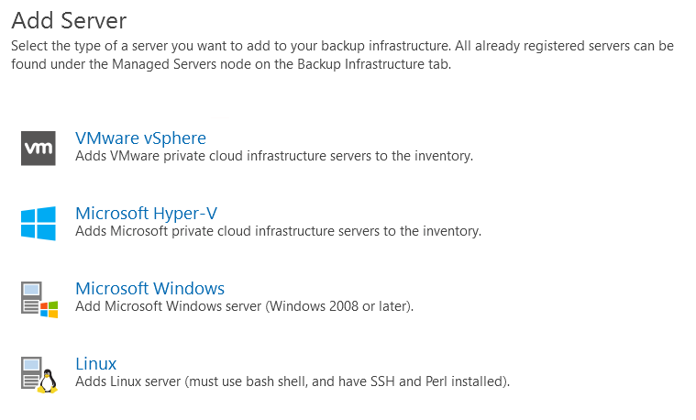

Select the ‘Hyper-V’ option. Note that Veeam can directly backup SMB3 environments such as Storage Spaces Direct, while utilising optimization technologies such as Remote Direct Memory Access (RDMA) for acceleration.

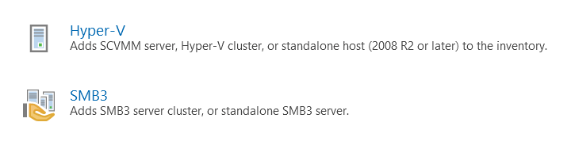

Add your Hyper-V server either by DNS hostname or IP Address.

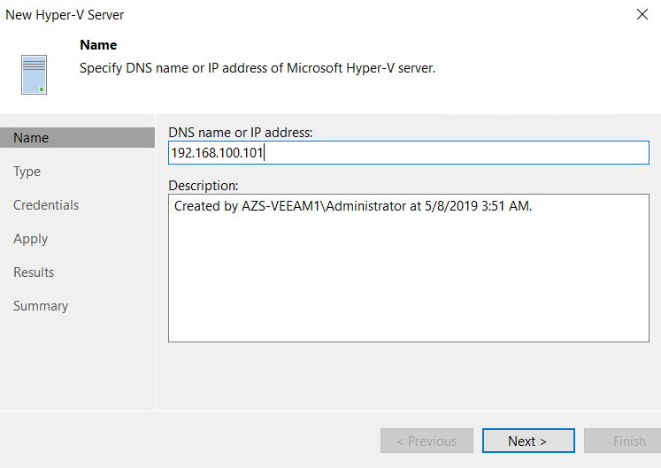

If your Hyper-V instance is manged with SCVMM then you’ll need the VMM console installed on your Veeam server as well. In this case we’re targeting a standalone Hyper-V server, so select that and click Next.

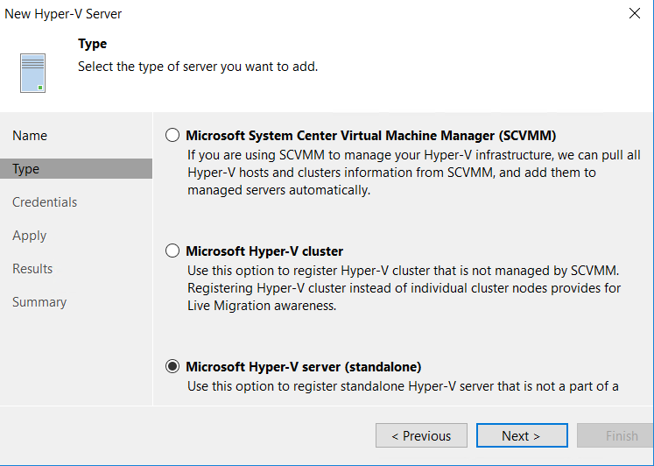

Enter appropriate credentials which will have administrative rights to the Hyper-V environment.

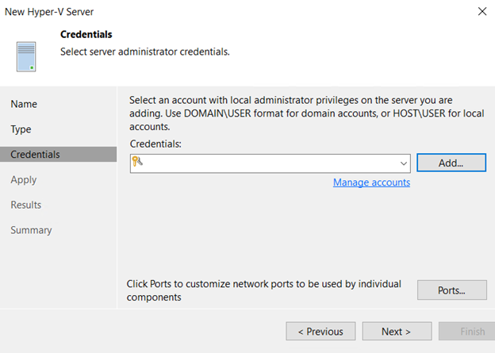

If required integration components are already installed on the Hyper-V environment then they’ll show as ‘already exists’, otherwise you’ll be prompted to install them. This doesn’t require a reboot. Select Apply to install/apply settings.

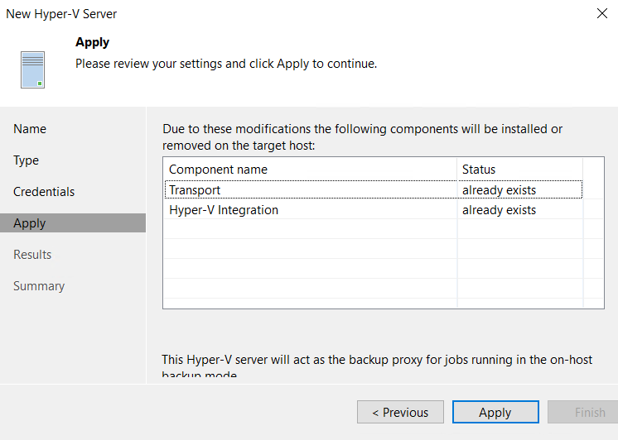

Once the server shows as added successfully, click Next.

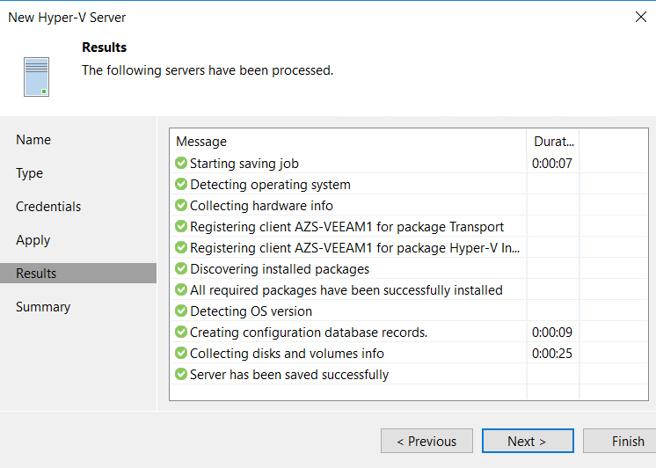

A deployment summary is displayed, click Finish to complete addition of the Hyper-V server.

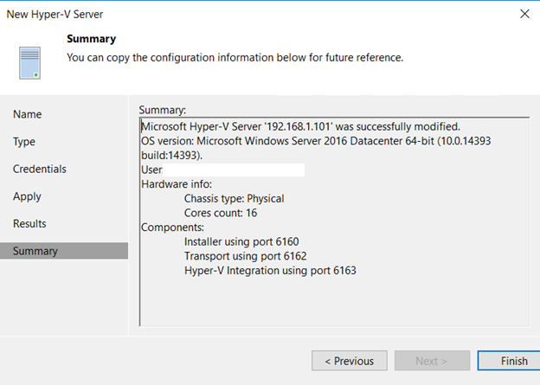

## Backup Virtual Machine from Source Environment

Now that the Hyper-V host is added, the VMs running on it can be viewed in the Inventory tab under ‘Hyper-V Standalone Hosts’ as below.

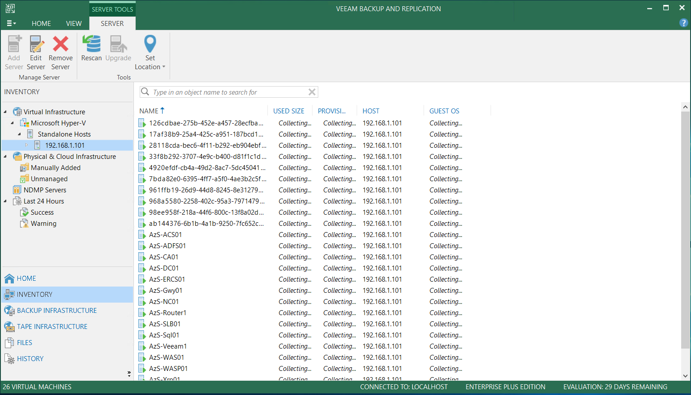

Right click on the server you want to configure backup for, and select ‘Add to backup job’.

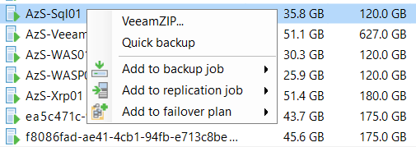

Name the backup job as you prefer.

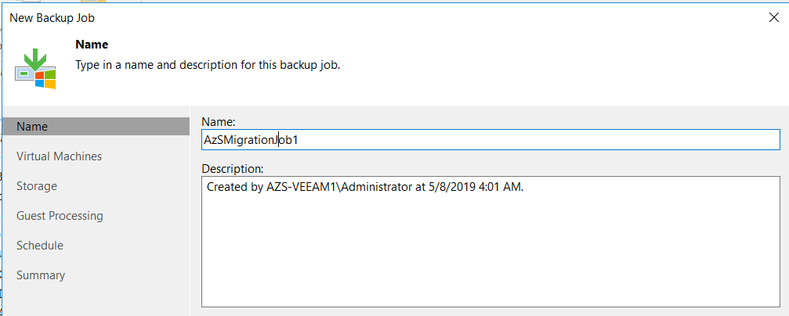

Ensure the correct VM or VMs are selected for backup.

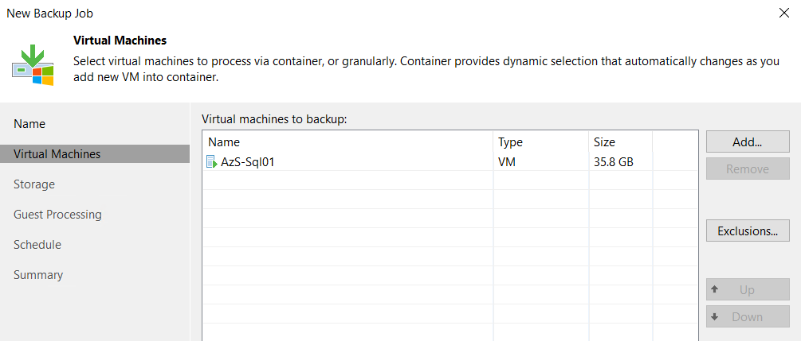

If an off-host proxy is installed or can be configured, this can offload processing from the Hyper-V host.

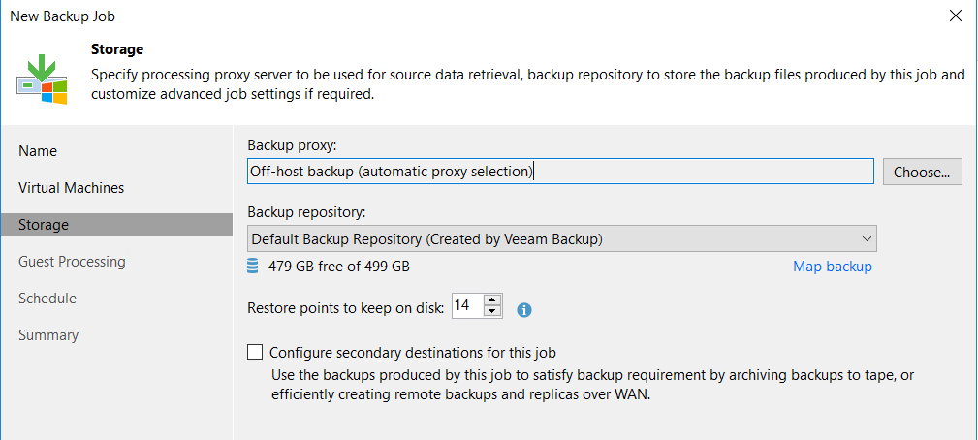

For workloads such as SQL servers or File servers, application aware or guest file indexing can be enabled to enable enhanced consistency and granular recovery options.

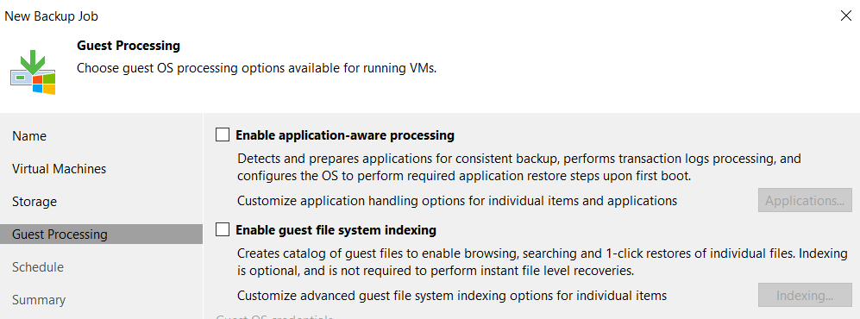

For backup purposes you would typically configure a backup schedule for the VM/s to be backed up during. As we’re taking a one time backup to perform a migration, we’ll leave this unchecked.

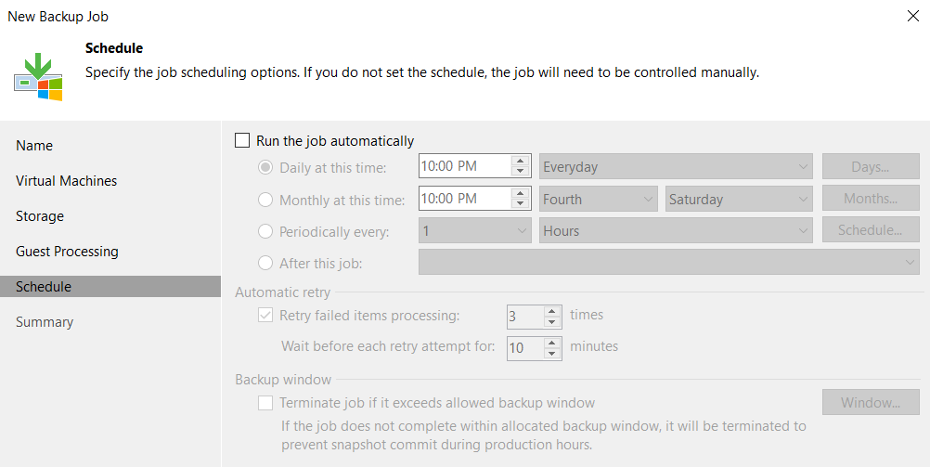

Verify the settings, and ensure that the ‘Run the job when I click Finish’ box is selected, then click Finish.

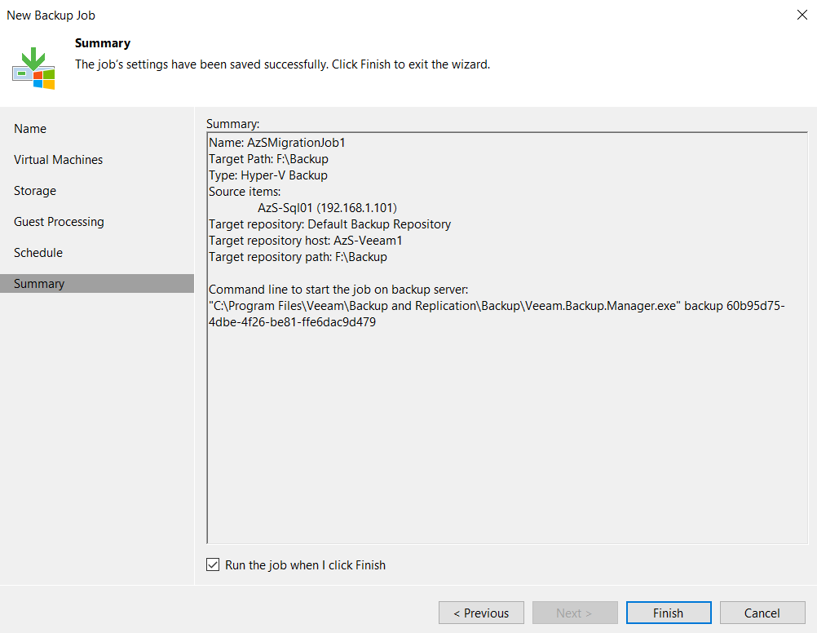

Click on the Home tab, and view currently running jobs to see the newly created backup job running.

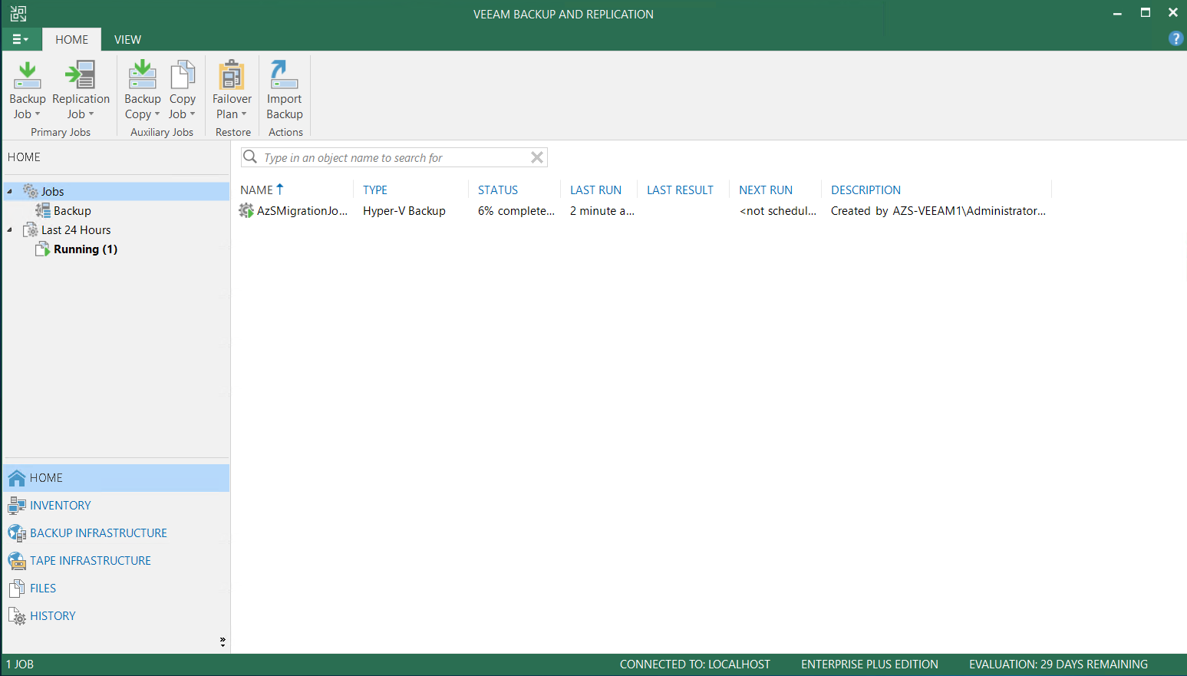

Wait for the backup job to finish, and show Last Result as ‘Success’.

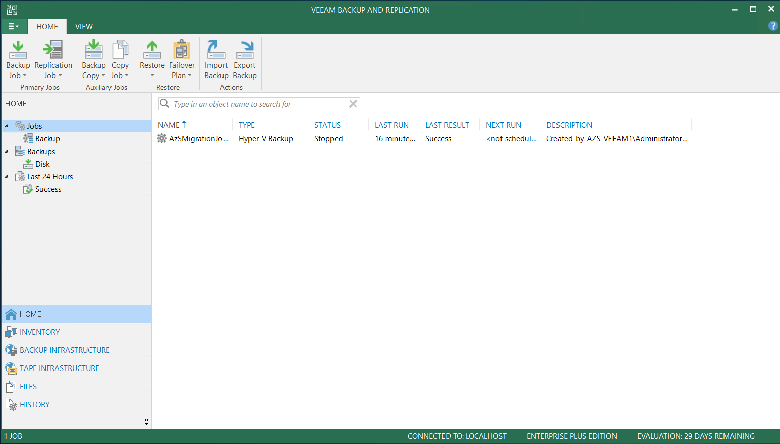

## Restore Virtual Machine to Target Environment

In order to restore the backup to the Azure Stack environment, navigate to the Home tab, then select Backups, expand the Backup Job, and select the VM server name.

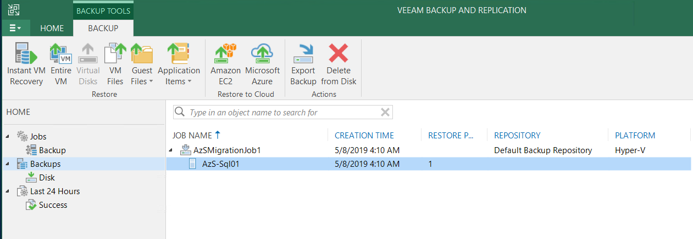

Right click the VM name, and select ‘Restore to Azure’.

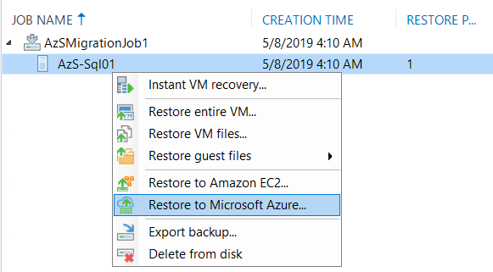

 If this is the first time an Azure restore has been performed, you’ll be prompted to run an initial configuration task.

Veeam Backup and Replication 
Initial configuration has not been performed yet. 
Do this now? 
Yes 
No 

Read the initial configuration information page, then click ‘Next’.

Initial Configuration 
Initial Configuration 
Add or edit your Microsoft Azure account to enable direct restore Of any backupto Microsoft Azure. 
Deployment Type 
Subscription 
Summary 
Registering your Microsoft Azure account enables you to leverage Veeam Disaster Recovery in Microsoft Azure 
solution, which includes Direct Restore to Microsoft Azure and Veeam PN for Microsoft Azure. 
Direct Restore to Microsoft Azure is an additional restore option that lets you restore backups of Windows and 
Linux virtual machines, physical servers and workstations directly to the Microsoft cloud for disaster recovery or 
migration purposes. 
Veeam PN for Microsoft Azure is a light weight software-defined networking solution that allows you to easily 
and securely establish netvaork connectivity to the restored computers from your datacenter. 
Next 
Cancel 

To restore to an Azure Stack environment, select ‘Microsoft Azure Stack’. If you do not see this option, you have a version of Veeam prior to 9.5 Update 4.

Initial Configuration 
Deployment Type 
Choose whether you want to register a public cloud or on-prem deployment Of Microsoft Azure. 
Initial Configuration 
Connection Settings 
Summary 
o 
Microsoft Azure 
Register an account for the public cloud computing service hosted in a global network of 
Microsoft-managed data centers. 
Region: 
IGlobal 
@ Microsoft Azure Stack 
Register an account for a hybrid cloud computing service delivering Microsoft Azure services from a private 
or service provider's data center. 
previous 
Next 

 At this point you will need to know your Azure Stack management endpoint. This will be the tenant endpoint, not the admin endpoint. Typically it will be in the format management.*region.domain.tld*. For the Azure Stack Development Kit, this will be management.local.azurestack.external. Enter credentials which will have deployment rights to a subscription in the tenant space of this Azure Stack and click Next.

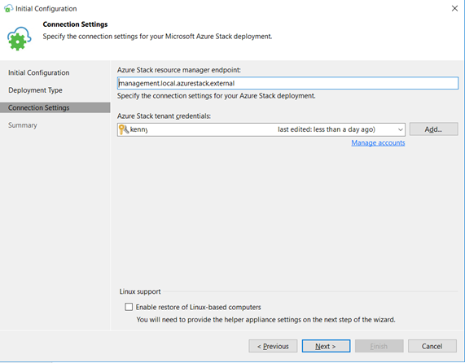

Ensure that your appropriate subscriptions are displayed as available to restore to, and click ‘Finish’.

Initial Configuration 
Summary 
Initial configuration has been completed successfully. Click Finish to exit the wizard. 
Initial Configuration 
Deployment Type 
Connection Settings 
Summary: 
ou are all set to perform restores Of your Veeam backups directly to Azure. 
Subscriptions: 
ASDK Subscription 
previous 
Finish 
Cancel 

Before proceeding, a restore to Azure Stack requires a few pre-requisites to be configured in the Azure Stack portal. These are:

* A Storage Account – Veeam doesn’t yet support restoring to Managed Disks
* A VNet – a virtual network must be created in advance
* A Network Security Group (NSG) (*Optional*) if VNet level firewall ports need to be configured.

Machine generated alternative text:
Microsoft Azure Stack 
Create a resource 
All services 
FAVORITES 
Dashboard 
All resources 
Resource groups 
App Services 
Function ADDs 
p Search 
resources 
Home ) All resources 
All resources 
KennyLowe 
Add 
Edit columns 
Refresh 
Subscriptions: ASDK Subscription 
Filter by name... 
3 items Show hidden types O 
veeamrestore 
veeam-restore-net 
veeam-restore-nsg 
Delete 
All resource groups 
v 
Storage account 
Virtual network 
Network security group 
All types 
RESOURCE GROUP 
vm-restore-rg 
vm-restore-rg 
vm-restore-rg 
v 
No grouping 
LOCATION 
local 
local 
local 

 Once these pre-requisites are created, the VM can be restored into Azure Stack.

Right click again on the VM backup in the Veeam console, and select ‘Restore to Azure’. Select the appropriate subscription if your tenant credentials have access to more than one.

Restore to Azure 
Subscri ption 
Specify Azure subscription and data center region to restore to. 
Machine 
VM Size 
Resource Group 
Network 
Secure Restore 
Reason 
Ready to Restore 
Subscription: 
ASDK Subscription (kenny@kennylowe.org) 
Specify Azure subscription and data center region to restore to. 
Location: 
Choose the Azure data center region where the VMS should be restored to. 
use Azure proxy VM 
92.1681.101 
Using a proxy VM running in target Azure data center significantly improves restore performance. 
previous 
Next 
Cancel 

 Here you can choose to restore the VM as a different VM size than the original backed up VM was configured with, as well as select the pre-configured storage account to deploy into.

Restore to Azure 
VM Size 
Specify the storage account and disk type for the restored 
Machine 
Subscription 
Resource Group 
Network 
Secure Restore 
Reason 
Ready to Restore 
Azure VM configuration: 
Name 
Azs-sq101 
VM size 
Select VM size 
Storage account 
Select storage accoum 
Previous 
Next 
Finish 

 To demonstrate the ability to change VM size on the fly during restore, we’re selecting a 4 core, 8 GB VM SKU. Please note that the ‘Max Disks’ field matters, and varies from VM SKU to SKU. In this case, the VM being restored has 2x Data Disks, so will fit fine in this VM SKU. If it had more than 8x, deployment would fail.

AzS-SqI01 Size 
Size: 
(4 cores, 8.00 GB тетооу) 
Cores: 
Мах disks 
Метом. 
Storage account: 
veeamrestore 
4 
8 
Choose the storage account а VM should ђе placed 'п. 
ок 
Са псе! 

 Select the Resource Group to deploy into, which is typically the Resource Group the Storage Account and VNet are deployed into. You can also choose to rename the VM at this stage.

Restore to Azure 
Resource Group 
Specify the resource group to place the restored VM into. 
x 
Machine 
Subscription 
VM Size 
Network 
Secure Restore 
Reason 
Ready to Restore 
Resource group: 
Machine name 
VM name 
azs-sq101 
Resource group 
Previous 
Next 

If you prefer to add to a new Resource Group, it’s possible to create one at this stage.

AzS-Sq101 Resource Group 
Specify the resource g roup that serves as a container to help you 
manage a collection of Azure resources. 
@ Place VM into the existing resource group: 
vm-resto re-rg 
O 
Create a new resource group: 
Name: 

Select the pre-created Virtual Network and (optionally) Network Security Group (NSG).

Restore to Azure 
Network 
Specify the virtual network to connect the restored VM to. 
Machine 
Subscription 
VM Size 
Resource Group 
Secure Restore 
Reason 
Ready to Restore 
Virtual network 
Name 
Virtual network 
Select network 
Network security. 
Empty 
Previous 
Next > 

Select the appropriate VNet and Subnet.

Azs-sq101 Virtual Network 
Virtual network 
veeam-restore-net(vm-restore-rg) 
Specify the virtual network to connect proxy VM to. 
Su b net 
frontend 
Choose an IP address range for the virtual network 

Assign a Network Security Group if required.

ppe 01 dn0J5 
:dn0J6 Klæroas 
dnoJD LOIbS-SZV 

Optionally, a VM can be scanned for malware prior to being restored. If required, select this option. Click Next.

Restore to Azure 
Secure Restore 
Scan the selected backup for malware, such as computer viruses or ransomware, prior to performing the restore. This requires a 
compatible antivirus installed on the mount server specified for the corresponding backup repository. 
x 
Machine 
Subscription 
VM Size 
Resource Group 
Reason 
Ready to Restore 
Scan the restored VM for malware prior to performing the recovery 
The VM you are about to restore Will be scanned by antivirus software installed on the mount server to 
prevent the risk Of bringing malware into your environment. 
It malware IS detected: 
Abort VM recovery 
'V Proceed with recovery but connect the VM to a different network 
Target neuork: snot configured> Clickto change 
Scan the entire image 
Continue scanning remaining files after the first malware has been detected 
Previous 

Enter a reason for the restoration of this VM to Azure Stack.

Restore to Azure 
Type in the reason for performing this restore operation. This information will be logged in the restore sessions history for later 
Machine 
Subscription 
VM Size 
Resource Group 
Network 
Secure Restore 
Ready to Restore 
Restore reason: 
ive a reason for restoring to Azure S 
[J Do not show me this page again 
Next 
Cancel 

Review the settings, and click ‘Finish’.

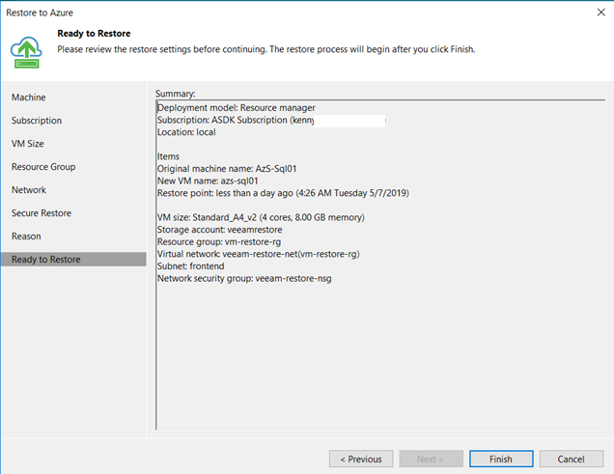

 Ensure the restore process runs to completion.

VM restore 
Name: 
Restore type: 
Initiated by: 
AzS-Sq101 
Restore to Azure 
AZS-VEEAMMdministrator 
Status: 
Start time: 
End time: 
Success 
5/7/2019 51831 AM 
5/7/2019 AM 
Statistics Reason Parameters Log 
Message 
O Starting restore job 
O Potential data sovereignty violation: target azs•sq101 location (local) does not match source 
O using Azure proxy AzS-Veeam1 
Queued for processing at 5/7/2019 AM 
Processing azs-sqIOI 
O Required backup infrastructure resources have been assigned 
O Restoring ScsiO• 1\CommonNuGets.vhdx (300 GB) : 8.1 GB restored at 23 MB's 
9 Restoring scsio-mwindowsservercore.vhdx (60.0 GB) 248 GB restored at 27 MB/s 
O Performing conversion 
O Creating Azure VM 
O Please wait for the first VM boot to complete, this may take a long time 
O Restore completed successfully 
Du rat. 
Close 

## Post Migration Verification Steps in Target Environment

Login to the Azure Stack tenant portal, and ensure that the VM shows as a new available Virtual Machine resource. Additional resources like Public IP Address and Network Interface should also have been created.

Microsoft Azure Stack 
+ Create a resource 
All services 
* FAVORITES 
Dashboard 
All resources 
Resource groups 
App Services 
Furrt•on Apps 
Virtual machines 
Recent 
P Search resources 
Home All resources 
All resources 
Ken 
Edit columns 
Refresh 
Subscriptions: ASDK Subscription 
Hirer by 
Show hidden types 
azs-sqIOI 
azs-sq101netinterface 
veeam•restore•net 
veea m-resto re-nsg 
Delete 
All resource groups 
V 
Virtual machine 
Public IP address 
Network interface 
Storage account 
Virtual network 
Network security group 
All types 
vm-restore-rg 
vm• restore-rg 
vm-restore-rg 
vm-restore-rg 
vm-restore-rg 

Select the deployed virtual machine, and click ‘Connect’.

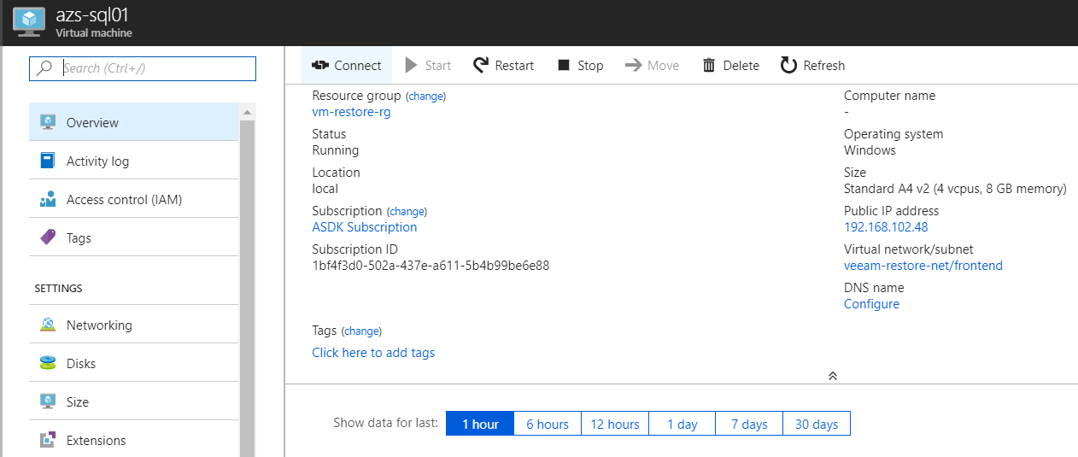

Download the RDP file.

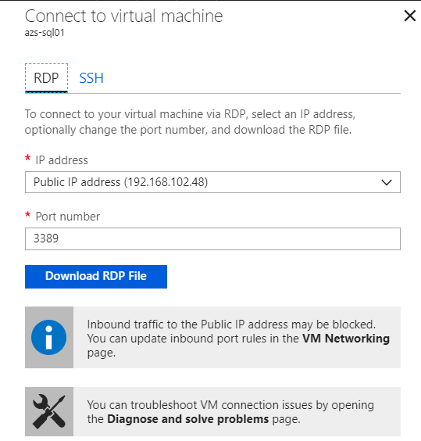

RDP to the deployed VM, and ensure that it functions as expected. The VM in this instance is running Windows Server Core.

